**PhonePe Pulse Dashboard – Power BI Project**

This repository contains a Power BI dashboard analyzing PhonePe Pulse data across Indian states and regions from 2018 to 2022. The project provides insights into digital transaction trends, top-performing states, regional contributions, and year-wise growth using interactive visuals.

**Project Overview**

This Power BI dashboard was created as part of a **guided masterclass by WsCube Tech**, where I learned how to work with real-world data and build interactive BI dashboards.

The project focuses on visualizing and interpreting UPI-based transaction data from the PhonePe Pulse dataset.

**Features & Visuals**

- Total transaction value: ₹121.41 Trillion

- Bar chart showing top contributing states (e.g., Telangana, Maharashtra, Karnataka)

- Pie chart representing region-wise contributions (South, West, Central, etc.)

- Year-wise transaction trends (line chart from 2018–2022)

- Stacked area chart for state-wise contributions over time

- Quarter filter to analyze seasonal transaction behavior

**Key Insights**

- Southern India leads in UPI transactions, contributing over ₹48T.

- States like Telangana, Maharashtra, and Karnataka dominate digital payments.

- Digital transactions have grown exponentially year by year, especially post-2020.

- Seasonal trends and regional breakdowns help understand user behavior patterns.

**Tools & Skills Used**

- Microsoft Power BI

- Power Query Editor

- DAX (Data Analysis Expressions)

- Data Cleaning & Modeling

- Data Visualization and Dashboard Design

**Dashboard image**

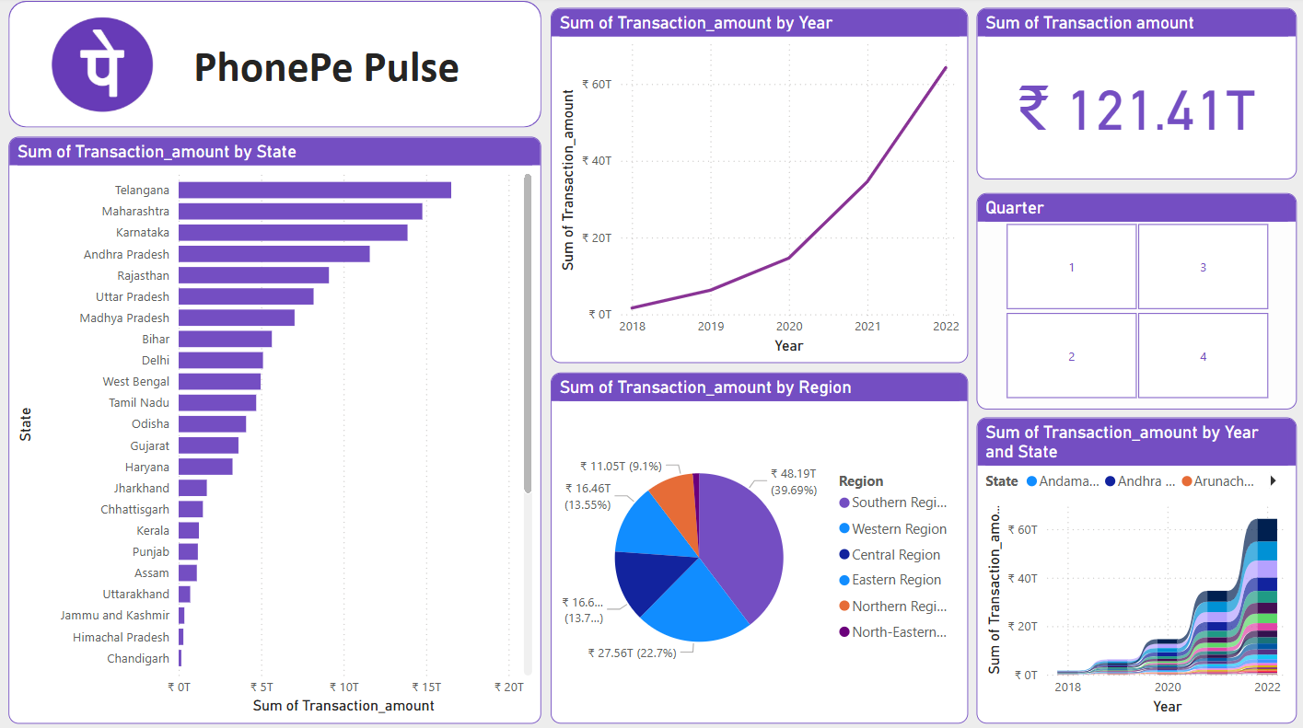

**About This Project**

This PhonePe Pulse Dashboard was created using Power BI as part of a guided masterclass by WsCube Tech.

It analyzes digital transaction trends in India from 2018 to 2022 using real PhonePe Pulse data.

The project demonstrates my skills in data cleaning, data modeling, DAX, and dashboard design using Power BI.